HOSTEL MESS MANAGEMENT SYSTEM
@CREATIVITY THINK (9483175986/7019689991)

ABSTRACT:
The Hostel Mess Management System is a web-based application designed to automate and simplify daily mess operations in hostels, colleges, and PG accommodations. The platform enables students to book meals, track attendance, make payments, and view their meal history through an interactive dashboard. Administrators can manage menus, monitor orders, handle payments, and access detailed analytics for meal consumption patterns. Developed using Django and the Django Rest Framework for backend operations, along with React, axios, and Recharts on the frontend, the system ensures transparency, accuracy, and efficient management of mess-related tasks..

INTRODUCTION OF THE PROJECT:
Traditional mess management practices often involve manual registrations, cash payments, and paper-based attendance systems, leading to inefficiencies and inaccuracies. The Hostel Mess Management System resolves these challenges by introducing a digital solution that integrates meal scheduling, attendance tracking, payments, and analytics. Students can conveniently book meals and monitor their usage, while administrators gain access to a unified dashboard that provides actionable insights. The platform enhances operational coordination, reduces errors, and promotes an organized mess management workflow..

PROJECT OBJECTIVES:

• Provide a convenient platform for students to book and manage meals
• Maintain accurate attendance records for breakfast, lunch, and dinner
• Enable secure online or offline payment tracking
• Provide administrators with a dashboard for monitoring overall activity
• Ensure smooth menu management and daily updates
• Enable download of receipts and monthly statements
• Enhance transparency and communication between students and mess managers

PROBLEM OF THE STATEMENT:
Hostel messes traditionally rely on manual registers, loose cash tracking, and irregular communication, resulting in inaccurate meal counts, financial discrepancies, and administrative delays. The absence of a centralized system also impacts forecasting and stock planning. The Hostel Mess Management System addresses these issues through automation, digital receipts, meal booking tracking, and dashboard analytics. This ensures reliable record-keeping, reduces manual workload, and enhances the efficiency of mess administration..

MOTIVATION OF THE PROJECT:
• To improve accuracy and transparency in mess operations
• To prevent loss of records and eliminate manual errors
• To provide students with a convenient online system for meal booking and payments
• To support hostel authorities in analyzing consumption trends and managing resources
• To build a robust digital alternative to traditional paper-based systems

BLOCK DAIGRAM OF PROJECT:

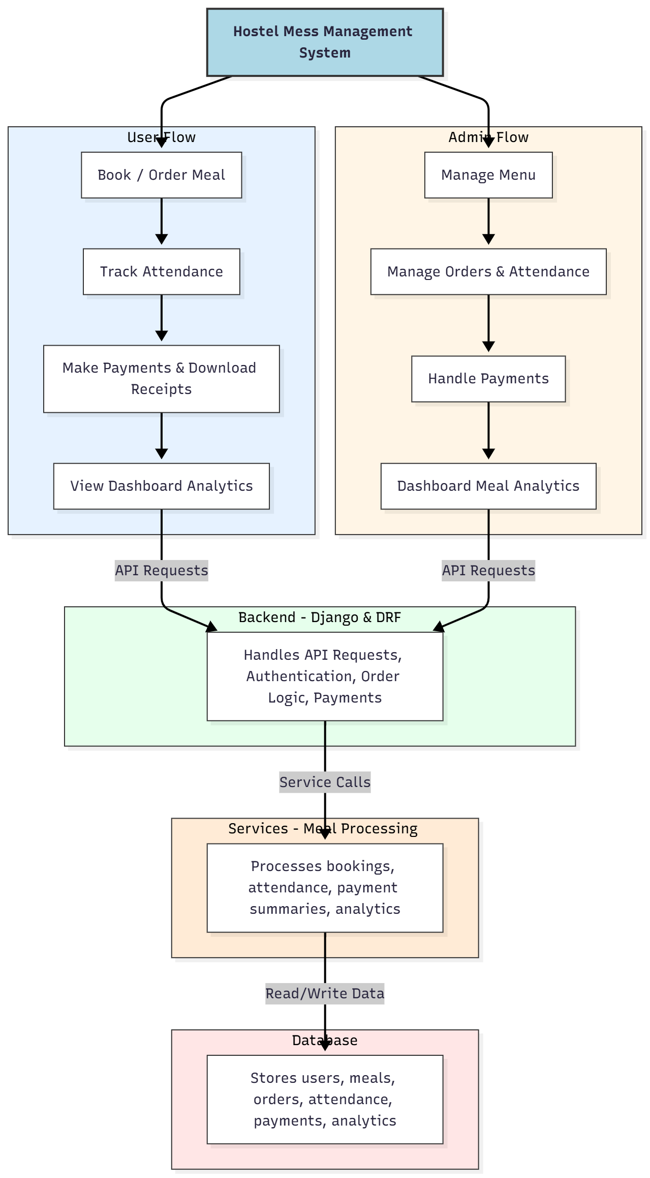

WORKING OF THE PROJECT:
The system begins with students logging into the web portal, where they can view the daily menu and book their meals. Each booking is recorded in the database and reflected on the user dashboard. Attendance is tracked digitally when students avail their meals, ensuring accurate consumption counts. Payments can be made digitally or marked manually, with receipts generated instantly.
Administrators have access to a comprehensive dashboard for managing menus, tracking daily orders, marking attendance, and reviewing payments. The backend processes all requests, validates workflows, and communicates with the database, while analytical services generate trend reports based on meal consumption and financial records. The system ensures seamless integration of all mess operations, improving both user satisfaction and administrative efficiency..

SOFTWARE REQUIREMENT:
- Backend:
  - Python 3.x
  - Django
  - Django REST Framework
  - SQLite/PostgreSQL
- Frontend:
  - Node.js and npm
  - React.js
  - Axios
- Development Tools:
  - Visual Studio Code
  - Postman (for testing APIs)
  - Git/GitHub (for version control)
- Server/Deployment (Optional):
  - Gunicorn, Nginx, or Heroku/AWS for hosting

ADVANTAGES OF THE PROJECT:

• Automates the entire meal booking and attendance process
• Ensures transparency in payments and attendance records
• Reduces manpower and eliminates paperwork
• Provides easy access to menus, receipts, and dashboards
• Helps administrators manage resources efficiently
• Offers real-time analytics for planning and forecasting
• Improves communication between students and management

APPLICATIONS OF THE PROJECT:
• Hostels in colleges and universities
• PG accommodations and dormitories
• Corporate hostels and staff quarters
• Military and training academy messes
• Boarding schools with dining facilities
• Anywhere routine meal service requires tracking and payment management

REFERENCES:

- Django REST Framework Documentation — Django Software Foundation. Django Documentation. Available: https://docs.djangoproject.com/
- Django REST Framework. DRF Documentation. Available: https://www.django-rest-framework.org/
- React. React Official Documentation. Available: https://reactjs.org/docs/getting-started.html
- Redux. Redux Documentation. Available: https://redux.js.org/introduction/getting-started
- PostgreSQL Global Development Group. PostgreSQL Documentation. Available: https://www.postgresql.org/docs/
- MySQL. MySQL Reference Manual. Available: https://dev.mysql.com/doc/
- Git. Git Documentation. Available: https://git-scm.com/doc
- Node.js. Node.js Documentation. Available: https://nodejs.org/en/docs/
- Axios. Axios Documentation. Available: https://axios-http.com/docs/intro
- Socket.io Documentation – https://socket.io/docs/

